8.1 Write a program in C, which pauses until it receives a key like Ctrl+C when pressed with a suitable warning massage.

Code:
#include<stdio.h>
#include<signal.h>

void signalMessege(int sig_num)
{
printf("Ctrl is pressed");
fflush(stdout);
}
int main()
{
signal(SIGINT,signalMessege);
while(1)
{

}

return 0;
}

output:

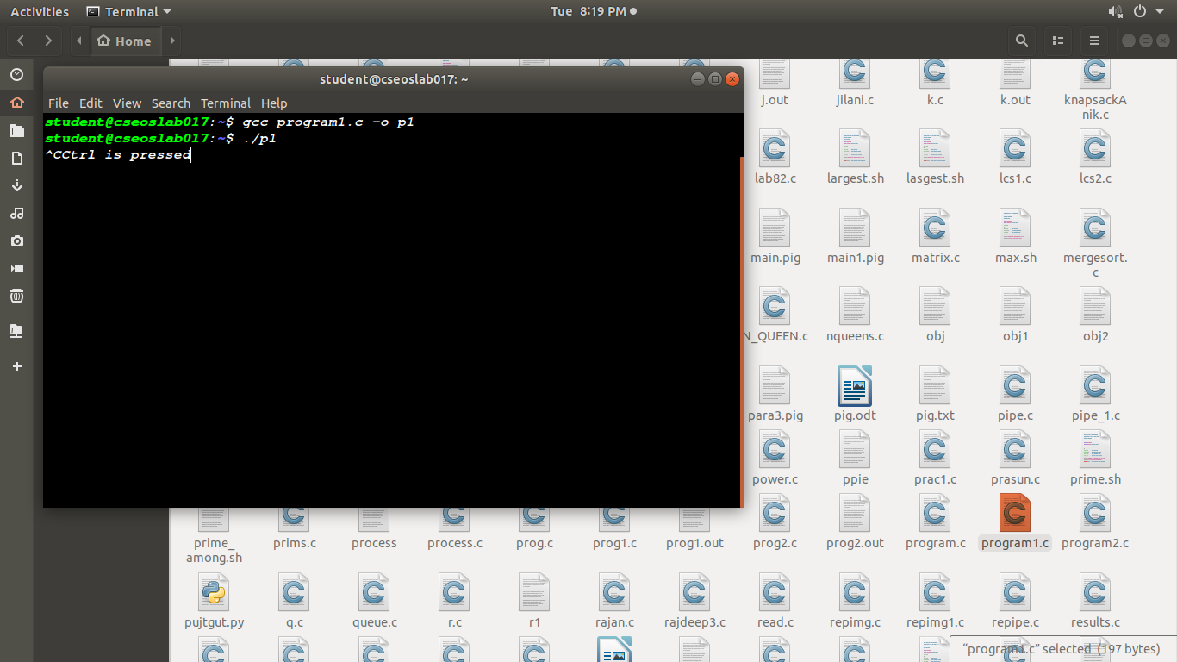

8.2 Write a program in C, that gives an alarm massage after every 2 seconds until the counter has exceeded 10.

code:
#include<stdio.h>
#include<unistd.h>
#include<signal.h>

void funAlarm(int sig_num)
{
printf("Alarmed");
fflush(stdout);
}
int main()
{
int count=0;
signal(SIGALRM,funAlarm);
alarm(2);
while(1)
{
count++;
pause();
printf("count=%d",count);
if(count >= 10)
break;
}

return 0;
}

output:
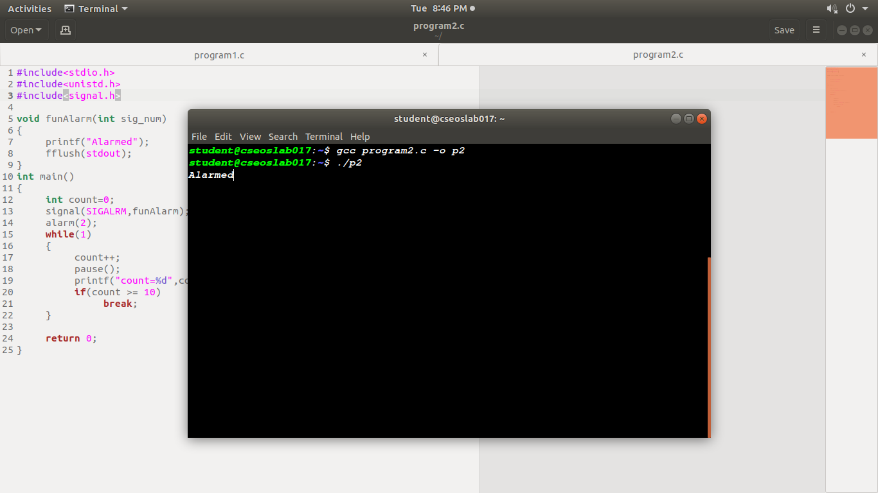
8.3 Write a program in C That calls SIGINT,SIGTERM SIGKILL externally from command prompt and note your observations

code:
#include<stdio.h>
#include<unistd.h>
#include<signal.h>

void funSignal(int sig)
{
if(sig == SIGINT)
printf("sigint called\n");
if(sig == SIGTERM)
printf("sigterm called\n");
if(sig == SIGKILL)
printf("sigkill called\n");

fflush(stdout);
}
int main()
{
signal(SIGINT, funSignal);
signal(SIGTERM, funSignal);
signal(SIGKILL, funSignal);

while(1)
{

}

return 0;
}

output1:
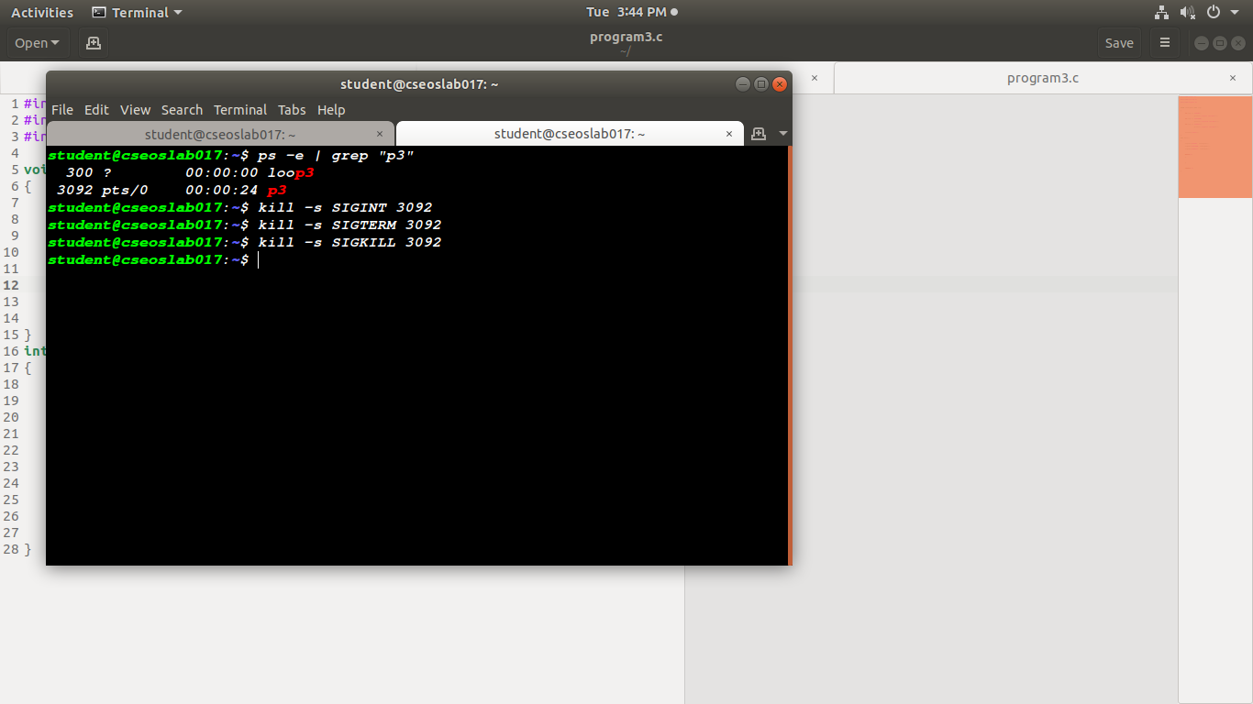
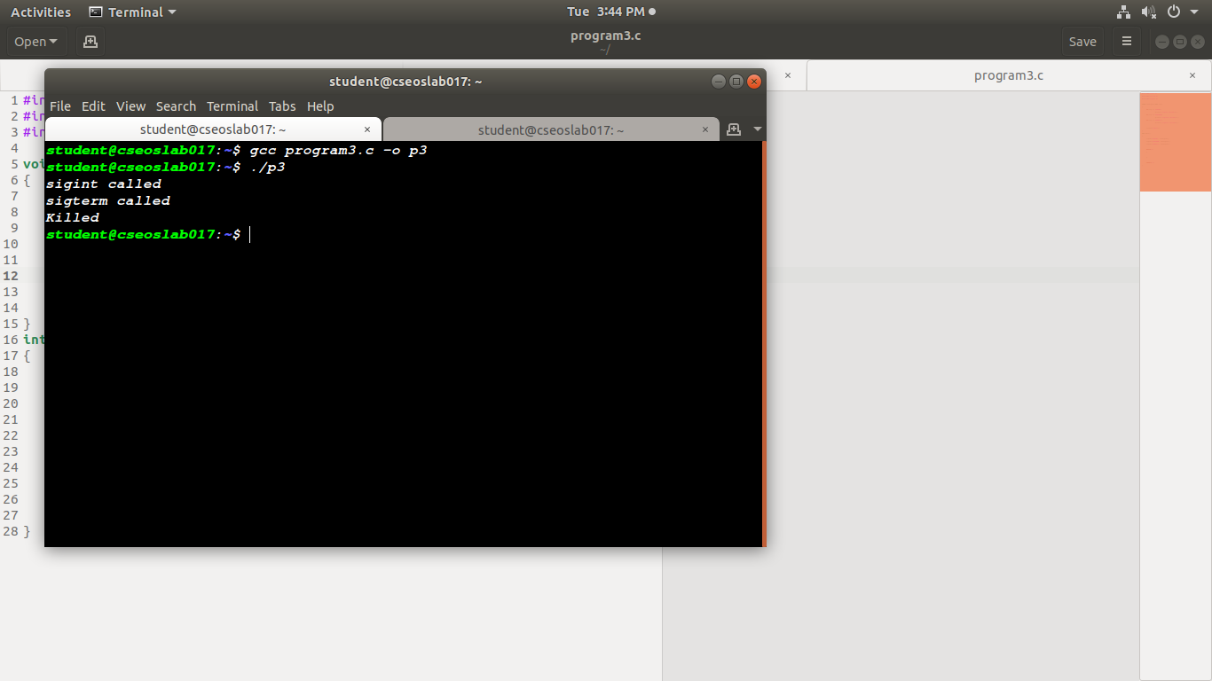

output2:

8.4 Write a program in C in which main will call a subroutine thread which will print count 10 times after that the program terminates. Try to depict the flow control from main to the subroutine thread and then back to main using statements.
Code:
#include<stdio.h>
#include<unistd.h>
#include<signal.h>
#include<pthread.h>
#include<stdlib.h>

void *funThread(void *p)
{
int count = 0;
printf("Thread begins\n");
while(1)
{
count++;
printf("count=%d", count);
sleep(1);
if(count>10)
break;
}
}
int main()
{
int a;
pthread_t th;
printf("main begins\n");
a=pthread_create(&th,NULL,funThread,NULL);
if(a != 0)
printf("Error in creation");
printf("main ends");
sleep(5);

return 0;
}

output:
